**CMSC 451 Homework 6**

1. Using Warshall’s algorithm, compute the reflexive-transitive closure of the relation below.

Show the matrix after the reflexive closure and then after each pass of the outermost for loop that computes the transitive closure.

$$\left[\begin{matrix}0 & 0 & 0 & 0 & 1 \\ 1 & 0 & 0 & 0 & 0 \\ 0 & 0 & 1 & 1 & 0 \\ 0 & 0 & 1 & 0 & 0 \\ 1 & 0 & 1 & 0 & 1\end{matrix}\right]$$

**Solution**

The following matrix results after the reflexive closure. The values that changed as a result are shown in red:

$$A0^{'}= \left[\begin{matrix}1 & 0 & 0 & 0 & 1 \\ 1 & 1 & 0 & 0 & 0 \\ 0 & 0 & 1 & 1 & 0 \\ 0 & 0 & 1 & 1 & 0 \\ 1 & 0 & 1 & 0 & 1\end{matrix}\right]$$

The following five matrices show the matrix after each iteration of the outer loop.

$$A1=\left[\begin{matrix}1 & 0 & 0 & 0 & 1 \\ 1 & 1 & 0 & 0 & 1 \\ 0 & 0 & 1 & 1 & 0 \\ 0 & 0 & 1 & 1 & 0 \\ 1 & 0 & 1 & 0 & 1\end{matrix}\right]$$

$$A2=\left[\begin{matrix}1 & 0 & 0 & 0 & 1 \\ 1 & 1 & 0 & 0 & 1 \\ 0 & 0 & 1 & 1 & 0 \\ 0 & 0 & 1 & 1 & 0 \\ 1 & 0 & 1 & 0 & 1\end{matrix}\right]$$

$$A3=\left[\begin{matrix}1 & 0 & 0 & 0 & 1 \\ 1 & 1 & 0 & 0 & 1 \\ 0 & 0 & 1 & 1 & 0 \\ 0 & 0 & 1 & 1 & 0 \\ 1 & 0 & 1 & 1 & 1\end{matrix}\right]$$

$$A4=\left[\begin{matrix}1 & 0 & 0 & 0 & 1 \\ 1 & 1 & 0 & 0 & 1 \\ 0 & 0 & 1 & 1 & 0 \\ 0 & 0 & 1 & 1 & 0 \\ 1 & 0 & 1 & 1 & 1\end{matrix}\right]$$

$$A5=\left[\begin{matrix}1 & 0 & 1 & 1 & 1 \\ 1 & 1 & 1 & 1 & 1 \\ 0 & 0 & 1 & 1 & 0 \\ 0 & 0 & 1 & 1 & 0 \\ 1 & 0 & 1 & 1 & 1\end{matrix}\right]$$

1. Using the matrix in the previous problem show the final result of executing Floyd’s algorithm on that matrix to produce a matrix containing path lengths.

**Solution**

The final matrix after executing Floyd’s algorithm is show below:

$$\left[\begin{matrix}0 & ∞ & 2 & 3 & 1 \\ 1 & 0 & 3 & 4 & 2 \\ ∞ & ∞ & 0 & 1 & ∞ \\ ∞ & ∞ & 1 & 0 & ∞ \\ 1 & ∞ & 1 & 2 & 0\end{matrix}\right]$$

1. Show the graph that corresponds to the matrix in the first problem assuming the rows and columns correspond to the vertices a, b, c, d and e. Show its condensation graph, renaming its vertices. Determine any topological order of that graph and create an adjacency matrix with the vertices ordered in that topological order. Finally compute the reflexive-transitive closure of that matrix. What characteristic of that matrix indicates that it defines a total order?

**Solution**

Adjacency matrix from the first problem:

$$\left[\begin{matrix}0 & 0 & 0 & 0 & 1 \\ 1 & 0 & 0 & 0 & 0 \\ 0 & 0 & 1 & 1 & 0 \\ 0 & 0 & 1 & 0 & 0 \\ 1 & 0 & 1 & 0 & 1\end{matrix}\right]$$

Which corresponds to this graph:

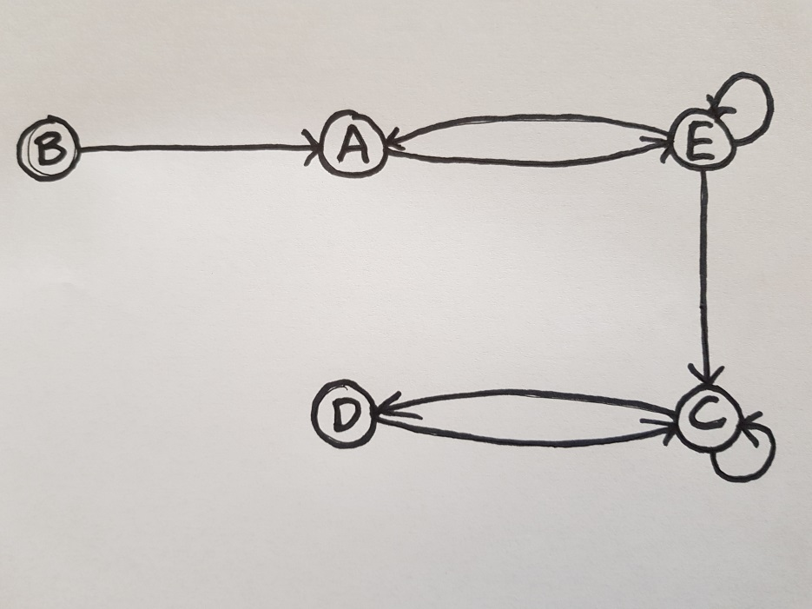

There are 3 SCCs. The vertices A and E form one, the vertices C and D form another, and the vertex B is its own SCC. The condensation graph is shown below:

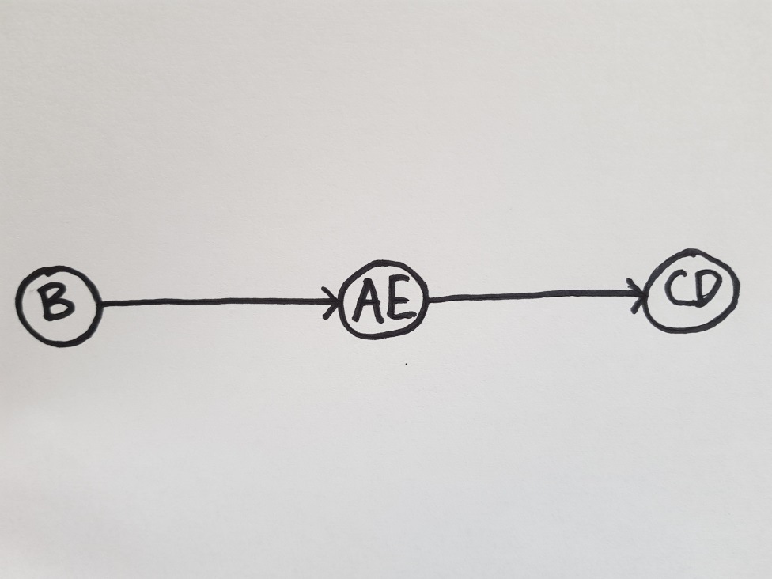

One topological order is B, AE, CD. The adjacency matrix with the vertices in that order is shown below:

$$\left[\begin{matrix}0 & 1 & 0 \\ 0 & 0 & 1 \\ 0 & 0 & 0\end{matrix}\right]$$

Performing the reflexive-transitive closure gives the following matrix:

$$\left[\begin{matrix}1 & 1 & 1 \\ 0 & 1 & 1 \\ 0 & 0 & 1\end{matrix}\right]$$

The resulting matrix is a right diagonal matrix, where all the elements below the main diagonal line are 0s and the ones on and above are 1s. This shows a total order.

4. Using Floyd’s algorithm, compute the distance matrix for the weight directed graph defined by the following matrix:

$$\left[\begin{matrix}0 & 4 & ∞ & 5 \\ 2 & 0 & 3 & 3 \\ ∞ & 2 & 0 & ∞ \\ -2 & ∞ & -4 & 0\end{matrix}\right]$$

Show the intermediate matrices after each iteration of the outermost loop.

**Solution**

The following four matrices show the matrix after each iteration of the outer loop. The values that changed as a result are shown in red:

$$D1=\left[\begin{matrix}0 & 4 & ∞ & 5 \\ 2 & 0 & 3 & 3 \\ ∞ & 2 & 0 & ∞ \\ -2 & 2 & -4 & 0\end{matrix}\right]$$

$$D2=\left[\begin{matrix}0 & 4 & 7 & 5 \\ 2 & 0 & 3 & 3 \\ 4 & 2 & 0 & 5 \\ -2 & 2 & -4 & 0\end{matrix}\right]$$

$$D3=\left[\begin{matrix}0 & 4 & 7 & 5 \\ 2 & 0 & 3 & 3 \\ 4 & 2 & 0 & 5 \\ -2 & -2 & -4 & 0\end{matrix}\right]$$

$$D4=\left[\begin{matrix}0 & 3 & 1 & 5 \\ 1 & 0 & -1 & 3 \\ 3 & 2 & 0 & 5 \\ -2 & -2 & -4 & 0\end{matrix}\right]$$

* **NOTE:** All problems were solved with algorithms implemented in the attached **CMSC451HW6.java** program.

**Grading Rubric**

|  |  |  |
| --- | --- | --- |
| **Problem** | **Meets** | **Does Not Meet** |
|  | **10 points** | **0 points** |
|  |  |  |
|  |  |  |
|  | Showed the correct matrix after the | Did not show the correct matrix after |
| **Problem 1** | reflexive closure (2) | the reflexive closure (0) |
|  | Showed the correct matrices after each | Did not show the correct matrices after |
|  | pass of the outermost for loop that | each pass of the outermost for loop |
|  | computes the transitive closure (8) | that computes the transitive closure (0) |
|  |  |  |

|  |  |  |  |
| --- | --- | --- | --- |
|  | **10 points** | **0 points** |  |
|  |  |  |  |
|  |  |  |  |
| **Problem 2** | Showed the correct final result of | Did not show the correct final result of |  |
| executing Floyd’s algorithm on that | executing Floyd’s algorithm on that |  |
|  |  |
|  | matrix to produce a matrix containing | matrix to produce a matrix containing |  |
|  | path lengths (10) | path lengths (0) |  |
|  |  |  |  |
|  | **10 points** | **0 points** |  |
|  |  |  |  |
|  |  |  |  |
|  | Showed the correct graph that | Did not show the correct graph that |  |
|  | corresponds to the matrix in the first | corresponds to the matrix in the first |  |
|  | problem assuming vertices a, b, c, d | problem assuming vertices a, b, c, d |  |
|  | and e (1) | and e (0) |  |
|  |  |  |  |
|  | Showed its correct condensation | Did not show its correct condensation |  |
|  | graph, renaming its vertices (2) | graph, renaming its vertices (0) |  |
|  |  |  |  |
|  | Determined a correct topological order | Did not determine a correct topological |  |
| **Problem 3** | of that graph (2) | order of that graph (0) |  |
|  |  |  |  |
|  | Created a correct adjacency matrix | Did not create a correct adjacency |  |
|  | with the vertices ordered in that | matrix with the vertices ordered in that |  |
|  | topological order (1) | topological order (0) |  |
|  |  |  |  |
|  | Correctly computed the reflexive- | Did not correctly compute the |  |
|  | transitive closure of that matrix (2) | reflexive-transitive closure of that |  |
|  |  | matrix (0) |  |
|  | Correctly explained what characteristic | Did not correctly explain what |  |
|  | of that matrix indicates that it defines a | characteristic of that matrix indicates |  |
|  | total order (2) | that it defines a total order (0) |  |
|  |  |  |  |
|  | **10 points** | **0 points** |  |
|  |  |  |  |
|  |  |  |  |
|  | Showed the correct intermediate | Did not show the correct intermediate |  |
| **Problem 4** | matrices after each iteration of the | matrices after each iteration of the |  |
| outermost loop using Floyd’s algorithm | outermost loop using Floyd’s algorithm |  |
|  |  |
|  | (7) | (0) |  |
|  |  |  |  |
|  | Showed the correct final matrix after | Did not show the correct final matrix |  |
|  | executing Floyd’s algorithm (3) | after executing Floyd’s algorithm (0) |  |
|  |  |  |  |